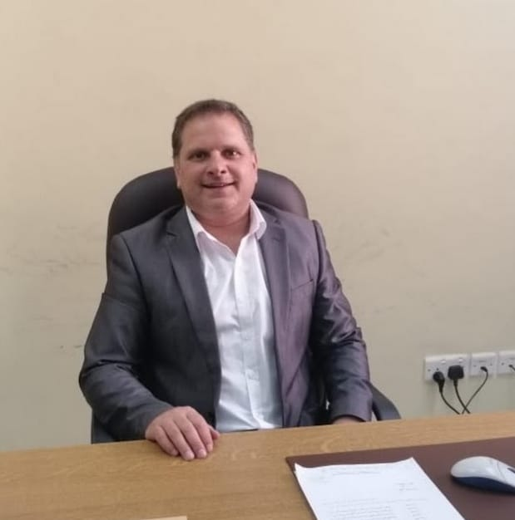
Curriculum Vitae

Personal information

Address

Telephone(s)

Fax

E-mail

Nationality

Date of birth

Gender
Marital Status

Desired employment / Occupational field

Education and training

Dates

Title of qualification awarded

Principal subjects/occupational skills covered

Name and type of organization providing education and training

Anas ABU KARAKI

Al Hussein Bin Talal University, 20, Ma'am, Jordan

00962-3-2179000 ext:7030 Mobile: 00962-798081609

00962-3-2179020

anas@ahu.edu.jo

Jordanian

19/06/74

Male
Married.

Associate Professor

2016

(PhD) Decision Support System

The Impact of Computer Technology on the Quality of Decision- Making in Strategic approach.
OmDurman Islamic University (University)

P.O.Box 382 OmDurman- Sudan

2003

Master Of computing (Networking)

University of Western Sydney (University) Locked Bag1797, 1797 Benrith South DC NSW (Australia)

1997

B.SC. Computer science
Israa University (University) 11622 Amman (Jordan)

Academic Experience

Dates

Occupation or position held

TEACHING EXPERIENCE

ADMINSTRATIVE EXPERIENCE

2018- Present
Assistant Professor, Department of Computer Science, Al Hussein Bin Talal University (AHU), Ma’an, Jordan.

2003-2017
Lecturer, Department of Computer Science,
Al-Hussein Bin Talal University (AHU), Ma’an, Jordan.

2000 - 2002

Computer Lap Supervisor

Taught the practical subject for computer skills I, II computer Maintenance web design

Al Hussein Bin Talal University, Al Hussein Bin Talal University ,P.O.Box 20 , Ma’an (Jordan) Public University

1998 - 2000

Lecturer and programmer

Lecturer and supervisor for graduation senior student Al- Alamiah Institute for computer and Technology - Almadeanah, Jeddah (Saudi Arabia) Private institution

1. Database Systems 2. Operating system
3. Decision support system and expert system

4. Systems Analysis 5. Computer Network I 6. Introduction to Network

7. Programming language I 8. Programming language II 10. Computer Security
11. Information Security 12. Managing IT projects 13. Information System

14. Visual Basic 15. Programming Computer Skills 16. Computer Skills 2
17. Computer Maintenance 18. Fundamentals of Information Systems

19. Fundamentals of Information Technology 20. Introduction to programming languages
21. Computer science Graduation project
22 Software Engineering Graduation project
23 Information System Graduation project

2018- 2020
Chair, Department of Software Engineering, AHU

2018- 2020
Coordinator of the International Program, AHU

2012-2013

Factory manager

Arab Suplier Fabrication And Retail SDN.BHD.

Factory: Pt 50760, jalan Wawasan 4/ku7, kawasan perindustrain Sungai Kapar , 42290
KaparKlang, Selangor , Malaysia

ADMINSTRATIVE EXPERIENCE

PUBLICATIONS REFEREED JOURNAL ARTICLES

2011 - /2012

Assistant Dean (collage of Information Technology) AHU

2004 - 2005
Director of computer center -AHU

2004 - 2005
Director of ICDL center AHU

- Anas Abukaraki, Tawfiq Alrawashdeh, Sumaya Abusaleh, Malek Zakarya Alkasasbeh, Bilal Alqudah, Khalid Alemerien and Hamzah Alshamaseen: Pulmonary Edema and Pleural Effusion Detection Using EfficientNet-V1-B4
Architecture and AdamW Optimizer from Chest X-Rays Images. Computers, Materials & Continua 18 July 2024 vol.80, no.1
- Anas abukaraki, A., Alrawashdeh, T., Alkore Alshalabi, I., Al-Jaafreh, M., Alksasbeh, M. Z., Alenezi, A., & Al-Kaseasbeh, M. (2024). New Algorithm for Evaluation of Online Courses Based on Quality Matters Rubric Using Fuzzy Soft Expert Sets. International Journal of Interactive Mobile Technologies (iJIM), 18(04), pp. 32–47.
- Bassam A. Y. Alqaralleh, Fahad Aldhaban, Anas Abukaraki , Esam A. AlQaralleh: Evolutionary Intelligence and Deep Learning Enabled Diabetic Retinopathy Classification Model. Computers, Materials & Continua 18 March 2022 Vol.73, No.1, 2022
- Malek Alksasbeh, Tamer Abu-Khalil, Bassam Alqaraleh, Anas Abukarki, Tawfeq Al-Rawashdeh, Mohamed Al-Jaffreh: Smart Detection of Offensive Words in Social media using Soundex Algorithm and Permuterm Index: International Journal of Electrical and Computer Engineering10/2021; 11(5).
- Malek Alksasbeh, Ahmad Al-Omari, Bassam Alqaraleh, Tamer Abu-Khalil, Anas Abukarki, Ibrahim Al-kore, Amal Alkaseasbeh: Smart Hand Gestures Recognition Using K-NN based Algorithm for Video Annotation Purposes. Indonesian Journal of Electrical Engineering and Computer Science 01/2021; 21(1):242-252.
- Tamer Abu-Khalil, Malek Alksasbeh, Bassam Alqaraleh, Anas Abukarki: Robot Navigation System Using Laser and a Monocular Camera: Journal of Theoretical and Applied Information Technology; 04/2020; 98(4) 714-724.
- Malek Alksasbeh, Mohammed Abuhelaleh, Mohammed Amin Almaiah, Mohamed AL-jaafreh , Anas Abukaraki :Towards a Model of Quality Features for Mobile Social Networks Apps in Learning Environments: An Extended the Information System Success Model. International Journal of Interactive Mobile Technologies
05/2019;13(5): 75-93.

MEMBERSHIP OF UNIVERSITY COMMITTEES

- Member of IT Faculty Council, AHU, 2019-2020
- Member of IT Faculty Council, AHU, 2018-2019
- Member of the Scientific Committee of the Faculty of Information Technology, AHU, 2019
- Member of the Committee to determine prices for the use of the facilities of the Petra College, 2019
- Member of the Committee for designing the Adventure of the Arabic Language Program for Speakers of Other Languages, 2019.
- Member of the Preparation and Coordination Committee with students and their supervisors for graduation projects, 2019.
- Chairman of the faculty interview committee in the Faculty of Software Engineering, 2018
- Member of the International Program Development Committee / Amman, 2018.
- Member of a committee to cooperate in making an agreement with the Royal Geographical Center, 2018
- Member, University Council, AHU,2017-2018
- Member of the faculty interview committee in the Faculty of Software Engineering, 2015.
- Member of IT Faculty Council, AHU, 2007-2008
- Member of the Committee corresponding to the position of Laboratory Supervisor 2006.
- Member of the Higher Committee for Student Elections at Al-Hussein Bin Talal University 2006
- Coordinator and secretary of the supervision committee to follow up the implementation of the information management system within the Higher Education Development Project 2005.
- Member of the Computer Center Committee at Al Hussein Bin Talal University 2005.
- Member of the Central tenders Committee at the University 2005
- Member of the steering committee of Jordanian Universities Network (JUNet), 2005.
- Chairman of the Information Printing Committee for each student, 2005.
- Member of the Preparatory Committee for the Scientific Conference on Computer and Information Technology 2005.
- Chairman of the Committee for Receiving Personal Computers, 2005.
- Member of the Study Committee for the Establishment of a Protection System for the Library of His Highness Prince Al-Hussein Bin Abdullah, 2005.
- Member of the Committee to study the applications of applicants for a computer maintenance technician job and make the interviewee for the applicants, 2005.
- Member of the committee studying the applications of applicants for a systems analyst job and interviewing them, 2005
- Member of the committee studying the applications of applicants for a programmer job and interviewing them, 2005.
- Member of the Committee to study applicants' applications for a job as an engineer and interviewing them, 2005.
- Member of the Central and Special Tender Committee of the Nabat Institute, 2005.

- Member of the Academic Advising Review and Activation Committee, 2005.
- Member of the Network Protection Systems Receipt Committee, 2004.
- IT Club Consultant, 2004.
- Member of the Committee to develop questions for applicants with a computer lab supervisor position, 2004.
- IT Club Consultant, 2003.
- Member of the Council of the Department of Computer Science at the Faculty of Information Technology, 2003 until today.
- Member of the Supreme Committee at the Thought Conference Hussein - Hussein Bin Talal University, 2001.

