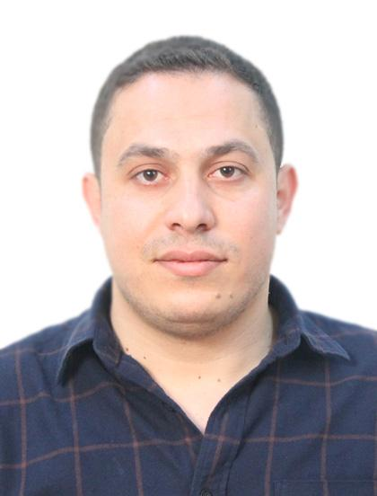
PERSONAL DETAILS
Full Name: Marwan Ahmed Mostafa Al-Shipli.
Nationality: Jordanian.
Date of Birth: 28.05.1987
Marital Status: Single
Phone No.: 00962776782263
E-mail: marwanayasrh@yahoo.com
EDUCATION
- 1/3/2016 - 28-3-2019. Studied a Doctor of Philosophy (PhD) in Radiation Technology
(Computed Tomography) at University of science, Malaysia
- 2014-2015. Studied Master Degree in Radiation science (mixed mode program) at
University of science, Malaysia. Overall average (3.73 of 4 )
- 2005-2009. BSC of Radiation Technology. – Faculty of Applied Medical Sciences –
Jordan University of Science and Technology. Overall average (70.1%)

- 2004-2005 GSEC– Scientific Section – Sakeb High School (85.2%)

SKILLS, COURSES, PUBLICATIONS AND EXPERIENCE
LANGUAGES:
Arabic: Mother tongue
English: Excellent reading, writing and speaking
COURSES:
- License from Saudi commission for health specialties in 2012 (PROMETRIC)

PUBLICATIONS
- Measurement of attenuation coefficients and CT numbers of epoxy resin and epoxy-based Rhizophora spp particleboards in computed tomography energyrange. (Radiation Physics and Chemistry 149 (2018) 41–48).
- Effect of slice thickness on image noise and diagnostic content of singlesource-dual energy computed tomography. (IOP Conf. Series: Journal of Physics: Conf. Series 851 (2017) 012005 doi:10.1088/1742-6596/851/1/012005)
- Beam Hardening Artifact and Image Noise in Single and Dual EnergyComputed Tomography Applications. (Journal of Advances in Chemical Engg., & Biological Sciences (IJACEBS) Vol. 5, Issue 1 (2018) ISSN 2349-1507 EISSN 2349-1515)
- Evaluating the Physical Properties of Epoxy Resin as a Phantom Material to Mimic the Human Liver in Computed Tomography Application. (Journal of Advances in Chemical Engg., & Biological Sciences (IJACEBS) Vol. 5, Issue 1 (2018) ISSN 2349-1507 EISSN 2349-1515P)
- Clustering technique to determinate signal-to-noise ratio of Rhizophora spp. binderless and araldite resin particleboard as phantom material on computed tomography images. (Journal of Physics:Conf. Series 1248 (2019) 012016 IOP Publishing doi:10.1088/1742 6596/1248/1/012016)
- Compatibility and validation of a recent developed artificial blood through the vascular phantom using doppler ultrasound color- and motion-mode techniques. (Journal of Medical Ultrasound) (2020)
- Image Quality and Dose Reduction in Single and Dual Energy Computed Tomography (Dissertation Submitted in Partial Fulfillment of the Requirements for the Degree of Master)
CONFERENCES
- PATTAYA 7th International Conference on Environmental, Chemical,Biological & Medical Sciences (ECBMS-17) (Pattaya, Thailand)
- 10th International Seminar on Medical Physics & 1st AMDI International Oncology Symposium (Penang , Malaysia)
- 18th. AOCMP and 16th. SEACOMP 2018 11th. – 14th. November 2018 (Kuala Lumpur, Malaysia)
- International Conference on Recent Advances in Medical Science (ICRAMS) / Barcelona, Spain during 11th - 12th February, 2020. (Barcelona, Spain)
EXPERIENCE
- 1/7/2009 - 1/12/2009 worked in Everest Digital Radiology Center - Amman/ Jordan as chief of radiologic technologist.

- 1/12/2009 - 31/8/2011 has worked at Istiklal Hospital - Amman Jordan as a radiologic technologist.

- 2/9/2012 - 1/7/2014 has worked at AL-Ghad International Medical Colleges - Jeddah / K.S.A as a clinical practice supervisor.

- 2/11/2015- 1/2/2016 has worked as a supervisor and senior in radiology department at Istiklal Hospital, Amman – Jordan.

- 4/2/2017-15/9-2017 and from 11/2/2018- until now , working as a full time lecturer at Radiography Department /Al-Hussein Bin Talal University, Ma’an –Jordan.

I WILL BE REALLY HONORED TO BE JOINED TO YOUR HIGHLY
QUALIFIED ESTABLISHMENT.

