Curriculum Vitae
Fuad Aref Ababneh
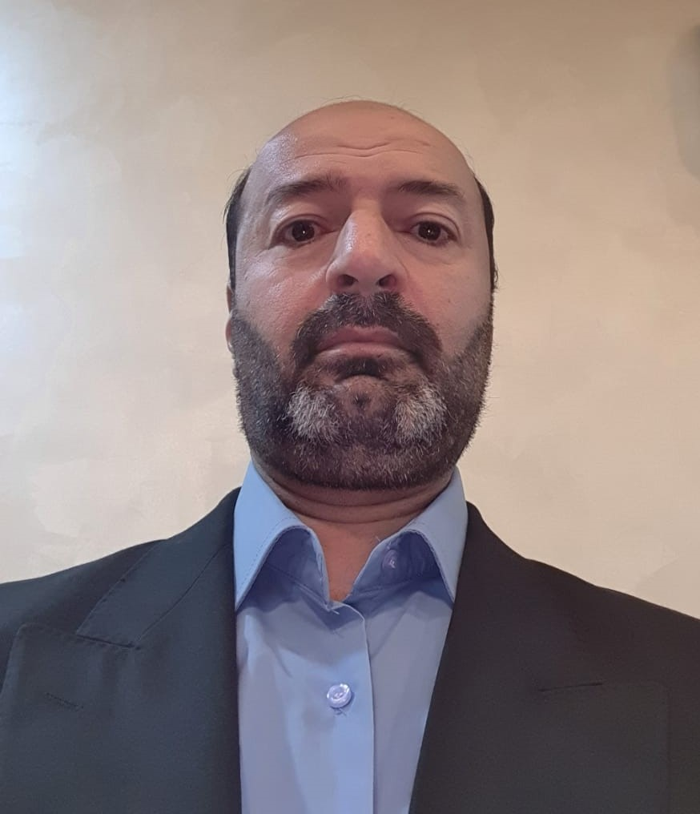
June 2021

Personal _________________________________________________
Place of Birth | Jordan
Date of Birth | November 29, 1968
Marital Status | Married
Nationality | Jordanian
Work Address | Department of Chemistry, College of Science, Al-Hussein Bin Talal University, Ma′an, Jordan. Phone: +962-3-2179000 Ext.:6311, E-mail: ababnehf@ahu.edu.jo
Academic Rank (date) | Associate Professor (2012)
Permanent Address | Irbid, Jordan. Cell Phone:+962-796556441, E-mail: ababneh89@yahoo.com

Academic Qualifications __________________________________________
2001 - 2005 | Ph.D., Analytical Chemistry, University of Ottawa, Ottawa, Canada
1991 - 1994 | M.Sc., Chemistry, Yarmouk University, Irbid, Jordan
1986 - 1990 | B.Sc., Chemistry, Yarmouk University, Irbid, Jordan

Specialty _________________________________________________________
General Specialization: | Chemistry
Specialization : | Analytical Chemistry

Career History ___________________________________________________
August 2020 -Present | Associate Professor, Department of Chemistry, College of Science, Al-Hussein Bin Talal University, Ma'an, Jordan.
August 2013 – August 2020 | Associate Professor, Department of Chemistry, Faculty of Science, Al-Imam Mohammad Bin Saud Islamic university , Riyadh- Saudi Arabia
October 2012 - August 2013 | Associate Professor, Department of Chemistry, College of Science, Al-Hussein Bin Talal University, Ma'an, Jordan.
August 2006 – October 2012 | Assistant Professor, Department of Chemistry, College of Science, Al-Hussein Bin Talal University, Ma'an, Jordan.

Administrative Experience _________________________________________
Committees: N.A
Positions : NA
HONORS, SCHOLARSHIPS, AWARDS AND GRANTS_________________
2001-2005 | Admission Scholarship and Excellence Scholarship Award- Faculty of Graduate and Postdoctoral Studies, Ottawa University, Ottawa, Canada

Professional memberships and Services _____________________________
Membership(s)
- American Chemical Society, 1998-1999
- Canadian Chemical Society, 2004-2005
- Jordanian Chemical Society, 2011-2014

Service(s)
- Jordan journal of chemistry (reviewer)
- Environmental Forensics (reviewer)
- International journal of environmental analytical chemistry( reviewer)

Research Interest ___________________________________________________
- Speciation analysis of heavy metal ions in water, air, soil and food.
- Applications of photo-catalyst in treating some environmental pollutants.
- Determination of hazardous species (toxic metals and trace organic residues) in food stuff, pharmaceuticals and environmental species

Publications ________________________________________________________
Peer-reviewed journal articles
- Fuad A. Ababneh, Abbas I. Alakhras , Mohamed Heikal , and Sahar M. Ibrahim "Stabilization of lead bearing sludge by utilization in fly ash-slag based geopolymer" Construction and Building Materials, 2019, 227 Article No. 116694 https://doi.org/10.1016/j.conbuildmat.2019.116694, Publication date: 10/12/2019
- Mohamed Heikal, Hamdy A. Abdel-Gawwad , Fuad A. Ababneh "Positive impact performance of hybrid effect of nano-clay and silica nano-particles on composite cements" Construction and Building Materials, 2018, 190, 508–516 https://doi.org/10.1016/j.conbuildmat.2018.09.163

- Fuad A. Ababneh, and Idreese F. Al-Momani "Assessments of toxic heavy metals contamination in cosmetic products" Environmental Forensics, 2018, 19(2),134–142
https://doi.org/10.1080/15275922.2018.144890
- Fuad A. Ababneh "The hazard content of cadmium, lead and other trace elements in some medicinal herbs and their water infusions" International Journal of Analytical Chemistry, 2017, Article ID 6971916, 8 pages
https://doi.org/10.1155/2017/6971916

- Fuad A. Ababneh, and Idreese F. Al-Momani "Evaluation of Residual Amounts of Persistent Organic Pollutants and Traces of Heavy Metals in King Talal Dam", Research Journal of Pharmaceutical, Biological and Chemical Sciences, 5(5), 1121-1128, 2014 .
- Fuad A. Ababneh, Khalil Abu-Sbieh and Idreese F. Al-Momani" Evaluation of allergenic metals and other trace elements in personal care products", Jordan Journal of Chemistry, v 8, no 3, 2013.
- Fuad A. Ababneh ,"Assessments of Selected Essential Elements in Canned Tuna Marketed in Jordan", Asian Journal of Chemistry, 25(2), 1057-1062, 2013
http://dx.doi.org/10.14233/ajchem.2013.13418.
- Fuad A. Ababneh and Idrees F. Al-Momani " Levels of mercury, cadmium, lead and other selected elements in canned tuna fish commercialized in Jordan", International Journal of Environmental Analytical Chemistry, 93(7), 755-766, 2013
http://dx.doi.org/10.1080/03067319.2012.672981
- Wedyan, M.A., F.A. Ababneh and S. Al-Rousan " The Correlations between mercury speciation and dissolved organic matter in the sediment of the Red sea", American Journal of Environmental Science, 8 (4), 403-411.2012
- M. Al-Harahsheh, S. Kingman, C. Somerfield, F. Ababneh " Microwave-assisted total digestion of sulphide ores for multi-element analysis", Analytica Chimica Acta, 638, 101-105, 2009
doi:10.1016/j.aca.2009.02.030.
- Hassan Al-Reasi, Fuad Ababneh, David Lean "Evaluating Mercury Biomagnification in Fish from a Tropical Marine Environment Using Stable Isotopes (δ¹³C and δ¹⁵N) " Environmental Toxicology and Chemistry, 26(8), 1572–1581, 2007
https://doi.org/10.1897/06-359R.1
- Fuad A. Ababneh, Susannah L. Scott, Hassan A. Al-Reasi, David R. S. Lean " Photochemical reduction and reoxidation of aqueous mercuric chloride in the presence of ferrioxalate and air” Science of the Total Environment. 367 (2-3), 831-839, 2006
https://doi.org/10.1016/j.scitotenv.2006.02.018.
- Khalid, M. T; Fuad, A. A., “ Conductance study of the binding of K⁺ by dibenzo-pyridino -18-crown-6 in acetonitrile” J. Incl. Phen. Recog. Chem. 29 (1), 15-22, 1997
https://doi.org/10.1023/A:1007923632191.

Books and book chapters
- N.A
Patents
- N.A.

Conferences And Proceedings _____________________________________
- Metals in the Environment Research Network (MITE), Annual Research Symposium, Crown Plaza, 101 Lyon Street, Ottawa, Ontario, Canada, February 27-28, 2001.

- The 87th Canadian Chemistry Conference and Exhibition, London, Ontario, Canada, May 29- June 1st 2004

Teaching__________________________________________________________
Courses Taught-undergraduate, At Al-Hussein bin Talal University
- General Chemistry I(CHEM 101)
- General Chemistry II (CHEM 102 )
- Analytical Chemistry I (CHEM 211)
- Analytical Chemistry Lab ( CHEM 212)
- Analytical Chemistry II( CHEM 411)
- Environmental Chemistry (CHEM413)
- Instrumental Analysis ( CHEM 311)
- Instrumental Analysis lab( CHEM 313)
- Chemistry of everyday life (CHEM 201)
- Chemical literature (CHEM 470)

Courses Taught-postgraduate
- N.A

Skills__________________________________________________________
Languages
- Arabic (native)
- English (excellent)

Computer Programs
- N.A

